An information system for the students of Agra University



Submitted in partial fulfillment of master of computer application (M.C.A) course

Submitted by
Mr. Rameshwar Singh
Roll No. – 2009015251012

M. C. A. – 4th Semester Dr. Bhimrao Ambedkar University, Agra (UP) INDIA

Under the supervision of
Mrs. Pratibha Rasmi
(Assistant Professor)
Department Of Computer Science, Institute of Engineering & Technology Khandari, Agra University
2020-2022
Declaration
I hereby certify that the work which is being presented in the Project entitled “An information system for the students of Agra University” by “Rameshwar Singh (2009015251012)” in partial fulfillment for the award of the degree of Master of Computer Application during the academic session 2020-2022 submitted in the Department of Computer Science And Engineering at Agra University is an authentic record of my own work carried out during the third semester under the supervision of Mrs. Pratibha Rasmi , The matter presented in this Project has not been submitted by us to any other University/ institution for the award of any other degree or diploma.

Date: Rameshwar Singh (2009015251012)
Place:

Acknowledgment
It is my immense pleasure to submit this project report on “An information system for the students of Agra University”. At the very onset, I would like to express my deepest and sincerest gratitude to “Mrs. Pratibha Rasmi” (Assistant Professor of Computer Science and Engineering Department Agra University, Uttar Pradesh) for her utmost guidance and support. The resources, vision and guidance provided by him during my project work were invaluable in various aspects of the project. We thank her for giving me the opportunity to grab the knowledge about HTML and PHP language, CSS and Java Script with this project.
I would like to thank my Head of the Department “Dr. Manoj Upadhyay” for his constructive criticism throughout my Project work.

I am also thankful to our family, friends, and the faculty members of Agra University, Paliwal Park, Agra (U.P.) 282004 India.

Rameshwar Singh (2009015251012)

Certificate
This is to certify that the report entitled “An information system for the students of Agra University” is a bonafide record of project work carried out by Rameshwar Singh (2009015251012) at Agra University is submitted in partial fulfillment for the award of the degree of Master of Computer Application for the academic session 2020-22. He has carried out his project under the guidance and supervision of Mrs. Pratibha Rasmi.

This approval does not necessarily endorse or accept every statement made, opinion expressed, or conclusion drawn as recorded in the report. It only signifies the acceptance of this report for the purpose for which it is submitted.

Date: Dr. Manoj Upadhyay
Head of Department of Computer Science and Engineering
Agra University
Agra, India

Certificate
This is to certify that the report entitled “An information system for the students of Agra University” submitted to the Department of Computer Science and Engineering, Agra University in partial fulfilment for the award of the degree of Master of Computer Application, is a record of project work carried out by Rameshwar Singh (2009015251012) under my guidance and supervision during the period from January 2022 to August 2022. All support received by them from various sources have been duly acknowledged. No part of this report has been submitted elsewhere for the award of any other degree or diploma.

Date: Mrs. Pratibha Rasmi
Department of Computer Science and Engineering
Agra University
Agra, India

Certificate
This project entitled “An information system for the students of Agra University” was submitted Rameshwar Singh (2009015251012) at Agra University. in partial fulfillment of requirements for the degree of Master of Computer Application (MCA) of Agra University has been examined.

Examiner
Date:
Place:

Abstract
The main purpose of this Project was to design and develop a user-friendly, responsive website with an admin panel for easy maintenance of the website. An information system for the students of Agra University can be used by education institutes to maintain the records of students easily. Achieving this objective is difficult using a manual system as the information is scattered, can be redundant, and collecting relevant information may be very time-consuming. All these problems are solved using this project.

Contents
Chapter 1 Introduction………………………………………………………10
1.1 Project Introduction
1.2 Project Profile

Chapter 2 Initial System Study……………………………………………..11-12
2.1 Problem Definition
2.2 Proposed System
2.3 Scope of Project

Chapter 3 Software Requirement Specifications………………………...…13-15
3.1 Primary Investigation
3.2 Expectation from new System
3.3 Typical Phase of Software development life cycle
Chapter 4 Feasibility Study…………………………………………………..16-17
4.1 Technical Feasibility
4.2 Economical Feasibility
4.3 Operational Feasibility
Chapter 5 Data Flow Diagram………………………………………………..18-23
5.1 Contest level DFD
5.2 Level 0 DFD
5.3 Frist level DFD
5.4 Frist level DFD
5.5 Record updating module
Chapter 6 E-R Diagram……………………………………………………….24-33
6.1 File Structure of an information system for the under graduate student Agra University
6.2 Relation module
6.2.1 What is Relation module?
6.2.2 Table used in Project
6.3 Relation Module

Chapter 7 Tools and Techniques Used………………………………………34-43
7.1 Front-End
7.1.1 HTML
7.1.2 CSS
7.1.3 JavaScript (JS)
7.1.4 Bootstrap
7.2 Backend
7.2.1 XAMPP localhost
7.2.2 mysql
7.2.3 Creating database and in string data
7.2.4 Creating of database in my-sql PHP my Admin
7.2.5 Apache
7.2.2 PHP
7.2.3 PHP Framework
Chapter 8 System Testing………………………………………………..…….44-45
Chapter 9 Hardware & Software Requirements ………………..………......46-47
9.1 Hardware Requirement
9.2 Software Requirement
Chapter 10 Results………………………………………………………………48-64
Chapter 11 Conclusions ……………………………………………….….………..65
Chapter 12 Bibliography……………………………………………………..….66-67

Chapter-1
Introduction
1.1 Project Introduction
The software is developed in such a way that smooth functioning is performed, maintaining a cohesive relation between the various activities. The design has been made to reduce the effort involved in processing the activities of various departments thus diminishing the waiting time on part of users, increase system reliability and data rate.
The objective of the “An information system for the Under Graduate students of Agra University” is to allow the administrator of any organization to edit and find out the personal details of a student and allows the student to keep up to date with his profile. It’ll also facilitate keeping all the records of students, such as their id, name, mailing address, phone number, DOB, etc. So, all the information about a student will be available in a few seconds, therefore software is required to perform these tasks quickly and accurately so that no inconsistency could occur in the functioning of the daily tasks. Overall, it’ll make Student Information Management an easier job for the administrator and the student of any organization.
With the help of this project, we are easily up to date with the university notice and information and it will provide course (UG, PG) detail, syllabus, faculty, academic calendar, etc.

1.2 Project Profile
Problem Statement: To reduce the paperwork and tedious process of the existing Student information system, there is a need to develop an online management system.

- The person doing the project: Rameshwar Singh
- Guide: Mrs. Pratibha Rasmi
- Organization: Agra University
- Duration: Four months.
- Project Location: Agra University
- Environment: Positive working environment with a great learning curve

Chapter-2
Initial System Study
2.1 Problem Definition
To develop a user-friendly, responsive website with an admin panel for easy maintenance of the website.
2.2 Proposed System
In our proposed system we have the provision for adding the details of the students by themselves. So, the overhead of the school authorities and the teachers become less. Another advantage of the system is that it is very easy to edit the details of the student and delete a student when it is found unnecessary. The marks of the student are added to the database and so students can also view the marks whenever they want. Our proposed system has several advantages.

- User-friendly interface
- Fast access to the database
- Less error
- More Storage Capacity
- Search facility
- Look and Feel Environment
Any data like information of students generated at the site of members can be monitored and updated. Any member query can be attended with the help of relevant information stored in the system. Many times, member needs a duplicate copy of the report which can be easily found out from the system and sent to the member without much time.

2.3 Project Scope
Without a student information System, managing and maintaining the details of the student is a tedious job for any organization. The student Information system will store all the details of the students including their background information, educational qualifications, personal details, and all the information related to their resume.
The idea of this project is to develop software for carrying following activities:
- Complete details of the student’s records on the Screen.
- Addition of records for new student’s file.
- Modification of existing records in student’s file.
- Complete details of student’s name, father name, address, etc.
- Provide information for “An information system for the Under Graduate students of AGRA UNIVERSITY”.
- Managing database by providing deletion & updating facility.
- View & print records according to the user query.

Chapter-3
Software Requirement Specifications
3.1 Preliminary Investigation
It is the 1st phase of the information system development project. This phase only evaluates project requests it does not include the collection of the details to completely describe the system.
- To develop a complete picture of the proposed system details must be investigated further.
- The whole procedure of flow information and database.
- Determine the interaction or integration between phases.
- Determine the type of report needed by each division and for each type of program.
- Identify the merits and demerits of the current manual system.
- Identify a problem that exists in a current manual system.
- Collection of possible solutions to this problem by users.
- Determine the time for development and implementation.
- Determine the various checks for better or efficient work also security for the info and database.

3.2 Expectation from New System
Name of the Project: An information system for students of Agra university
Objectives:
- Online registration of students
- Maintenance of student records
- Searching student records

Users Views:
- Administrator
- Student
- Platform

Operating Systems: Microsoft Windows

Technologies Used:
- Front End: HTML and JavaScript
- Web designing language: PHP
- RDBMS (Back end): MySQL

Software Requirements:
- PHP 5.0
- APACHE HTTP Server
- Dreamweaver, FrontPage for Front End Programming
- Microsoft Windows or Linux

Hardware Requirements:
- Intel Pentium IV processor or equivalent or higher
- 512 MB Ram or Higher
- 20 GB HDD or Higher
- Network Connectivity
3.3Typical Phases of Software Development Life Cycle
Software analysis and design and
Software Requirements S/W specifications
Investigation and
Feasibility
Study
Coding

Implementation and
Maintenance Testing

Chapter-4
4.1 Feasibility Study
A feasibility study is a test of system proposal according to its workability, impact on the organization, ability to meet user needs and effective use of resources. Its focuses on three major questions:
- What are the user’s demonstrable needs, and how does a new purposed system meet them?
- What resources are available for the given purposed system? Is the problem-solving? What are the likely impacts of the purposed system on the organization? How well does it fit within the organization?
- Master MIS plan?
The feasibility study includes consideration of all the possible ways to provide a solution to the given problem. The proposed solution should satisfy all the user requirements and should be flexible enough so that future changes can be easily done based on the future upcoming requirements.
4.1 Economic Feasibility:
This is a very important aspect to be considered while developing a project. We decided on the technology based on the minimum possible cost factor.
- All hardware and software cost has to be borne by the organization.
- Overall, we have estimated that the benefits the organization is going to receive from the proposed system will surely overcome the initial costs and the later running cost of the system.

4.2 Technical Feasibility:
This included the study of function, performance, and constraints that may affect the ability to achieve an acceptable system. For this feasibility study, we studied the complete functionality to be provided in the system, as described in the Tools and Techniques Used, and checked if everything was possible using a different type of frontend and backend platforms.

4.3 Operational Feasibility:
No doubt the proposed system is fully GUI based is very user-friendly and all inputs to be taken all self-explanatory even to a layman. Besides, proper training has been conducted to let know the essence of the system to the users so that they feel comfortable with the new system. As far as our study is concerned the clients are comfortable and happy as the system has cut down their loads and doing.

Chapter-5
Data Flow Diagram
5.1 Context Level DFD

Display of user request

Webpage
On
Agra university

E Request the user
USER

Website on Agra university

5.2 Level 0 DFD

Students Admission
Personal Information

Student data Information Display

Student
information
system
Enquiry
Enquiry Registered
Enquiry data Enquiry Report

Help desk data Help desk entry
Help desk
Help desk Counter

5.3 First Level DFD
For
Login 1.1
Login 1.1
Admin Access
ID & password
Request for login Detail

Valid user
User

1.2
Main
Window
Invalid user

5.3 First Level DFD
For
login1.2
User updetion

User request
Verification

Verification name & ID Student record file
Updation &
Deletion module
Updation information

Name /ID location

Student record file

5.4 Second Level DFD

User record file
User
request verification
Search module
Student record file
Inquiry report

5.5 Record Updation Module

Admin Access
Login
Database update
View/Edit the database

[Invalid user id or password]

Chapter-6
E-R Diagram
E-R Diagram can express the overall logical structure of a database graphically. In E-R Diagram the emphasis is on representing the schemas rather than the instances. This is more useful because a database schema changes rarely, whereas the extension changes frequently. In addition, the schema is usually easier to display than the extension of the database, because it is much smaller. Such a diagram consists of the following major components.

- Rectangle, which represents an entity, sets.

- Ellipse, which represents attributes.

- Diamonds, which represent a relationship set.

- Lines, which link attribute to entity set and vice-versa.

- Derived attribute, represent attribute derived from other attributes.

USERNAME
PASSWORD
ID

Manages
NAME
_ID
CONTACT_NO

EMAIL

COURSE
FATHERNAME
ADMIN ACCESS
STUDENTS ADMISSION
NAME
NAME
EMAIL
ID
MASSEGE
DATE

HELPDESK
SrNO
Manages
MOTHERNAME
GENDER
ENQUIRY
CITY
ADMISSION DATE
DATE_OF_BIRTH
COURSE
Manages
DEGREE
CONTACT
EMAIL
FATHERNAME
DATE
ADDRESS
NATIONALITY
STATE
QUALIFICATION
As to above ERD shows, there are many to many relationships between student, Admin and Admission, Enquiry, Helpdesk.
Student’s attributes are id, name, address, and date of birth, father name, mother name, email, date, contact, course, qualification, degree, etc.
The website on Agra University provides an inquiry register, admission, and helpdesk.

6.1 File Structure of an information system for the students of Agra University
The project contains the following record which should be stored on the disk in the file. These records contain user information, ID, Student Name, FatherName, MotherName, Address, Course, Degree, Qualification, Date of Birth, and information related to their occupation. A record of user login will provide secure operation on software. Similarly setting a file will keep a record or information about the setting.

User Information: -
Field name | Type | Size | Constraint
ID | Int | 10 | Unique
DATE | Date | 20 | None
NAME | Varchar | 50 | Notnull
FATHER NAME | Varchar | 50 | Notnull
DATE OF BIRTH | Date | 20 | Notnull

Login Information: -
Field name Type Size constraint | Type | Size | Constraint
ID | Int | 10 | Notnull
USERNAME | Varchar | 50 | Unique
PASSWORD | Varchar | 50 | Unique

Help Desk Information: -
Field name | Type | Size | Constraint
DATE | Date | 20 | not-null
NAME | Varchar | 50 | Notnull
EMAIL | Varchar | 50 | Notnull
MASSAGE | Varchar | 50 | Notnull
ID | Bigint | 20 | Notnull

Admission statements information: -
Field name | Type | Size | Constraint
DATE | Date | 20 | Notnull
NAME | Varchar | 50 | Notnull
FATHER NAME | Varchar | 50 | not-null
MOTHER NAME | Varchar | 50 | not-null
DATE OF BIRTH | Date | 20 | not-null
GENDER | Varchar | 50 | not-null
MOBILE | Bigint | 20 | Notnull
ADDRESS | Varchar | 50 | Notnull
CITY | Varchar | 50 | not-null
STATE | Varchar | 50 | Notnull
NATIONALITY | Varchar | 50 | Notnull
COURSE | Varchar | 50 | not-null
QUALIFICATION | Varchar | 50 | Notnull
DEGREE | Varchar | 50 | not-null
ID | Bigint | 20 | Notnull

Enquiry Information: -
Field name | Type | Size | Constraint
DATE | Date | 20 | Notnull
NAME | Varchar | 50 | Notnull
FATHER NAME | Varchar | 50 | not-null
MOTHERNAME | Varchar | 50 | not-null
MOBILE | Bigint | 20 | Notnull
ADDRESS | Varchar | 50 | Notnull
COURSE | Varchar | 50 | not-null
DATE OF BIRTH | Date | 20 | not-null
SNO | Bigint | 20 | not-null
DEGREE | Varchar | 50 | not-null

6.2 Relational Model

6.2.1 What is the Relational Model?
The relational model represents how data is stored in Relational Databases. E-R (Entity-Relationship) Diagram is used to represents the relationship between entities in a table. ER diagrams represent the logical structure of databases. ER Diagram represents the relationship between two database tables.
Students from the main part of any institution that concerns with. But the institutions find it difficult to keep details of so many students of the organization just in one stretch. It will involve a lot of pen paper work. Sometimes there will be some huge heap of files bundled up and kept together in some corner of the office. It will be the files that will contain the details of the students of the institution. To solve all these problems, student information system applications can play a major role. The student information system ER (Entity Relationship diagram) will play a major role in illustrating the logical structure of the databases.

6.2.2 Table uses in the project
The relational model was proposed by E.F. Codd to model data in the form of relations or tables. After designing the conceptual model of the Database using ER diagram, we need to convert the conceptual model into the relational model which can be implemented using any RDBMS languages like Oracle SQL, MySQL, etc. So we will see what Relational Model is.
Admin

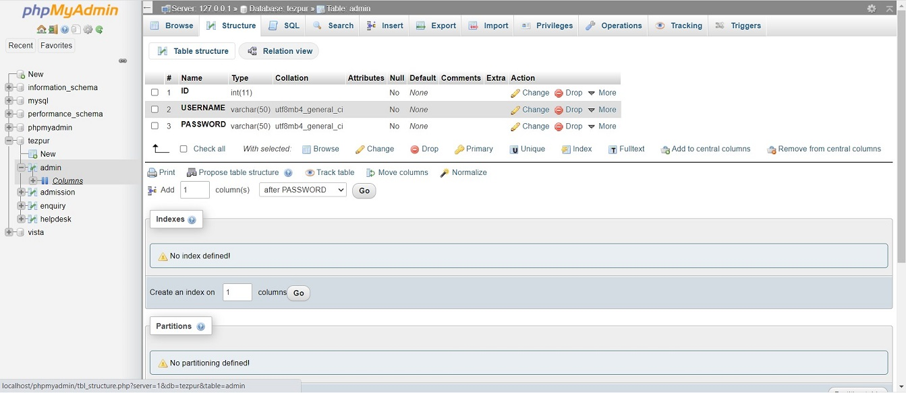
Admission

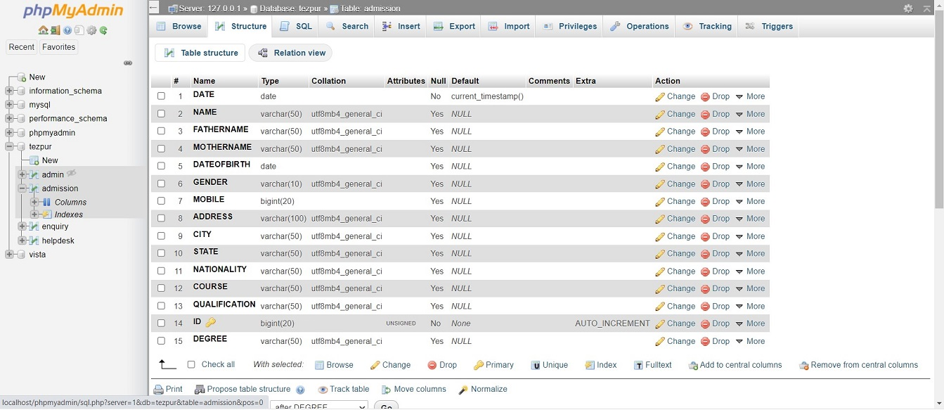

Enquiry

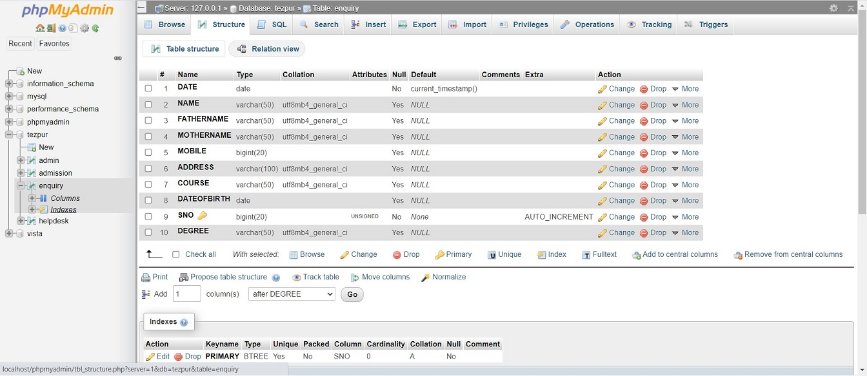
Helpdesk

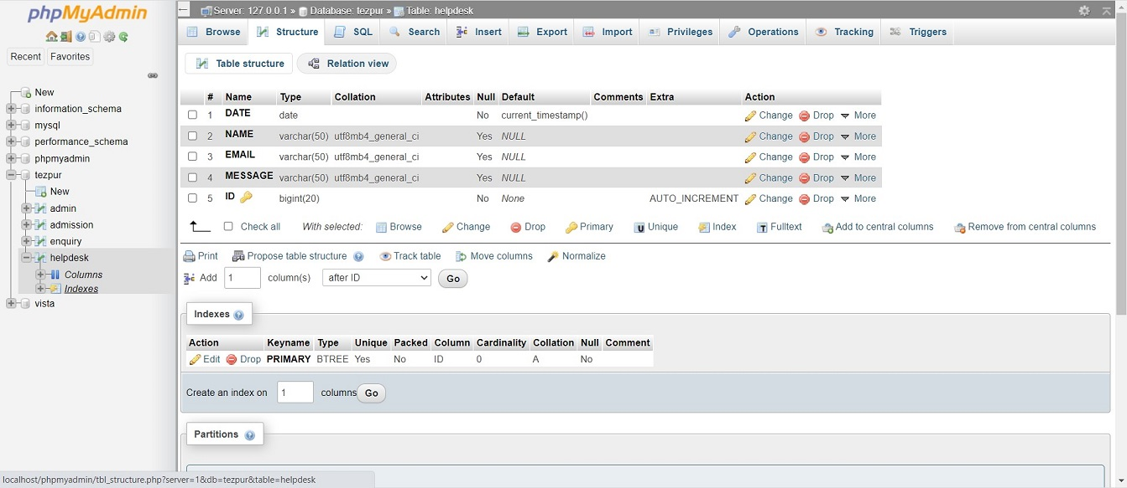

6.3 Relational Model
Admission
ID
NAME
FATHER NAME
MOTHER NAME
COURSE
CONTACT
QUALIFICATION
ADDRESS
Degree

COURSE
BE/B.TECH
BCA
BA
B PHARMA
B.COM

Login
ID
USRENAME
PASSWORD

Enquiry
SrNO
NAME
FATHER NAME
MOTHER NAME
COURSE
Degree

Admin Access
ID
USERNAME
PASSWORD

Help-Desk
ID
NAME
EMAIL
MASSAGE

Chapter-7
Tools and Techniques Used
Web development is the process of creating either a static or dynamic webpage or web application with the different technologies for the internet (WWW) or an intranet (a private network). The web development process can be broadly divided into two parts. The first part, Front-End consists of a User Interface (UI) of the web page i.e., how the page will look for the user. The second part is Back-end. It consists of all the databases and tables and concerns all the server-side programming. The technologies used in the project are briefly described below:

7.1 Front-End
Front-end is a part of website development where the view or design of a website is created using Front-end Development tools. The tools used in this project are explained below.

7.1.1 HTML
HTML stands for a Hyper Text Markup Language. It is a Markup language for creating web pages and websites. The elements of HTML are the building block of a website and are represented by tags. Tags do not render themselves on a webpage, but they help to render other content. Example of HTML tags is “body”, “head”, “title”, and “table”. The tags are enclosed in
Syntax: < body> </body>, <div> </div>.
Most of the tags have closing tags and they are represented as above.

7.1.2 CSS
CSS stands for a Cascading Style Sheet. It is used to add a style to HTML elements. It can be written in an HTML file or separately as a “.CSS” extension.

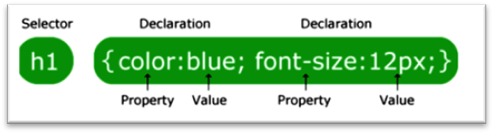
FIGURE 1. Standard CSS syntax
A standard CSS syntax consists of a selector and a declaration block as shown in figure 1. The selector points to the HTML element that one wishes to style. The property and value are separated by a colon (:). Each declaration block is surrounded by curly braces and each declaration ends with a semicolon (;).

7.1.3 JavaScript (JS)
JS is a high-level, interpreted programming language. It is a scripting language, primarily used on the Web. Being an interpreted language, it does not need to be compiled. It renders web pages interactively and dynamically. It is one of the three core technologies of the World Wide Web (WWW) along with HTML and CSS.

It is case sensitive and generally, the name of the function and variable is written in a lower case. Every statement is ended with a semicolon (;). For example, a variable is defined as: “var a = 10;”. Here ‘var’ is a data type of the variable ‘a’, ‘=’ is an operator which assigns a value ‘10’ to the variable ‘a’. <script> </script> is used in an HTML file to insert JS script into HTML. If a separate JS file is created its source must be pointed using an src attribute of <script>. Commonly JS is used for image manipulation, form validation, and dynamic changes in content. To select an HTML element, JS often uses a document. getElementById () method.
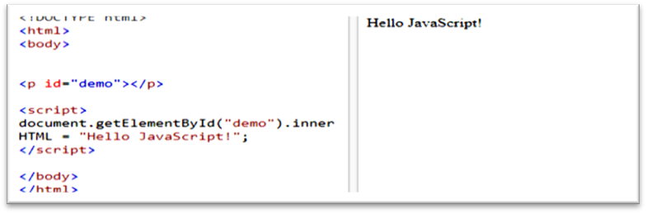
FIGURE 2. An example of the use of JS in HTML

This JavaScript example in figure 2 writes "Hello JavaScript!" into an HTML element with id="demo".

7.1.4 Bootstrap
Bootstrap is a free and open-source front-end library for designing websites and web applications. It contains HTML and CSS-based design templates for typography, forms, buttons, navigation, and other interface components, as well as optional JavaScript extensions. Unlike many web frameworks, it concerns itself with front-end development only.

Bootstrap can be downloaded from “getbootstrap.com” and then the link can be added to the source folder in the project as shown below:

<link href =” bootstrap.css (path)” type=”text/css” rel = “stylesheet”>
or it can be directly introduced to code as CDN (Content Delivery Network) without downloading as shown below:

<link rel="stylesheet"href=https://maxcdn.bootstrapcdn.com/bootstrap/3.3.7/css/bootstrap.min.css >
7.2 Backend
In the client-server model, the client is considered as a front-end and the server is considered as a backend, even though some presentation work is done on the server. The technology used for the backend part of the project is explained below.
7.2.1 XAMPP localhost
XAMPP is an acronym for macOS (also on Windows), the operating system; Apache, the web server; MySQL, the database management system; and PHP, Perl, or Python, all programming languages used for web development. XAMPP installs a local server environment on the firm’s computer. XAMPP was chosen as it was one of the most popular and easy-to-operate localhost servers and it has PhpMyAdmin.

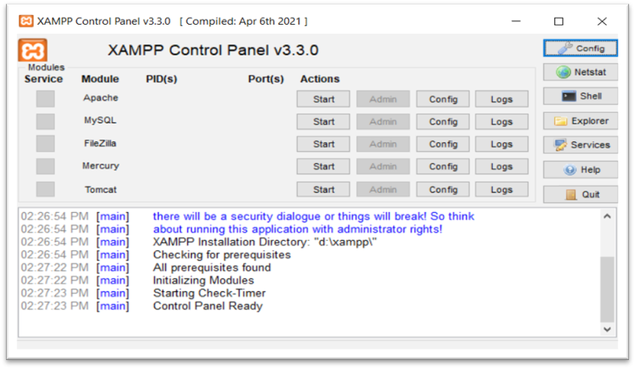
FIGURE 3. The appearance of the XAMPP localhost window

So, after the localhost was set up, the default XAMPP homepage could be run by clicking the Open start page as shown in figure 3, and figure 4 shows its web homepage.

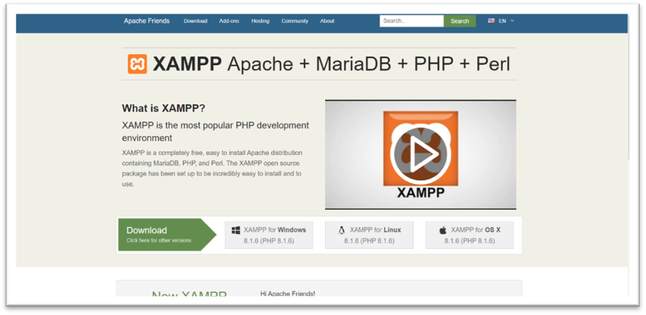
FIGURE 4. The homepage of XAMPP localhost
phpMyAdmin is a graphical interface for the management of a database. Because of the graphical interface, many MySQL queries could be operated directly into the server easily. Figure 5 shows the layout of the phpMyAdmin homepage.
7.2.2 MySQL
MySQL is a relational database management system (RDBMS) [1] that runs as a server providing multi-user access to several databases. MySQL is a popular choice of database for use in web applications and is an open-source product. The process of setting up a MySQL database varies from host to host; however, we will end up with a database name, a user name, and a password. Before using our database, we must create a table. A table is a section of the database for storing related information. In a table, we will set up the different fields which will be used in that table. Creating a table in phpMyAdmin is simple, we just type the name, select the number of fields and click the ‘go’ button. we will then be taken to a setup screen where you must create the fields for the database. Another way of creating databases and tables in phpMyAdmin is by executing simple SQL statements. We have used this method to create our database and tables.
7.2.3 Creating a Database and Inserting Data
Now that we have run and tested Apache and PHP, the next step is running MySQL and creating a database and table which will hold information to be used by our website. To start MySQL, navigate to the Xampp directory and run the mysql_start.bat batch file. The XAMPP package contains an application called phpMyAdmin which allows developers to administer and maintain MySQL databases. We will be using phpMyAdmin to create a database and table, and enter test data. Before testing phpMyAdmin, make sure that both Apache and MySQL are running by opening their respective batch files: apache_start.bat and mysql_start.bat. Along with Apache and MySQL running in the background, we type http://localhost/phpMyAdmin/ into our web browser. If successful we will be presented with a phpMyAdmin start page similar to the one shown below.

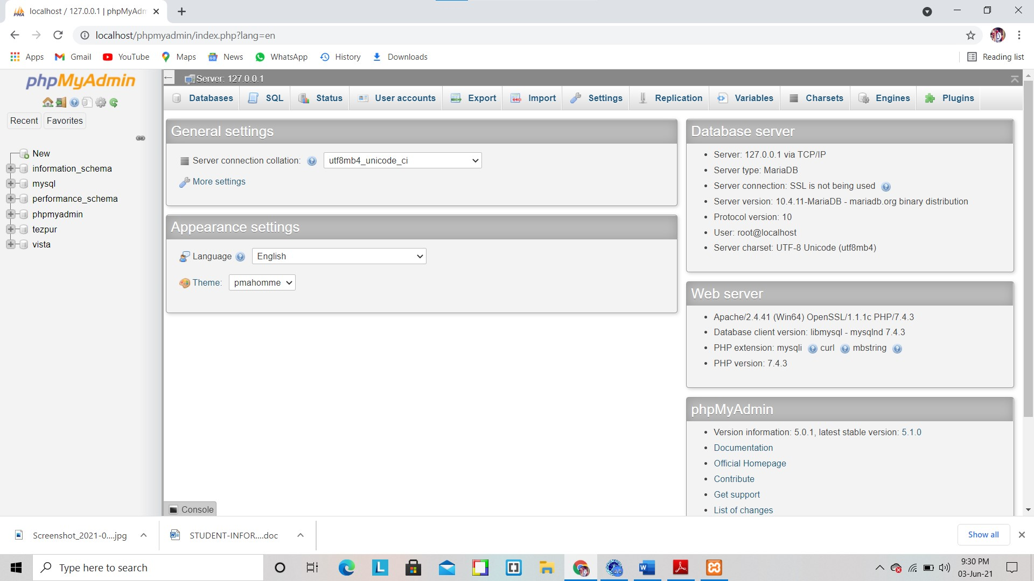
phpMyAdmin start page
The first step with phpMyAdmin running is creating a new database. We create a new database by directly executing SQL statements as shown below. The successful execution of the SQL query creates a database ‘student’ with two tables in it. The tables are admin_login and student information. We also inserted values in the admin table. The screenshot below shows the successful execution of the query thus the creation of a database named student.
7.2.4 Creation of database in MySQL using PhpMyAdmin
Thus, we have learned to create a database in MYSQL by executing SQL statements. After creating the database and tables we are now ready to use them on our website “An information system for the under graduate students of Agra university”.

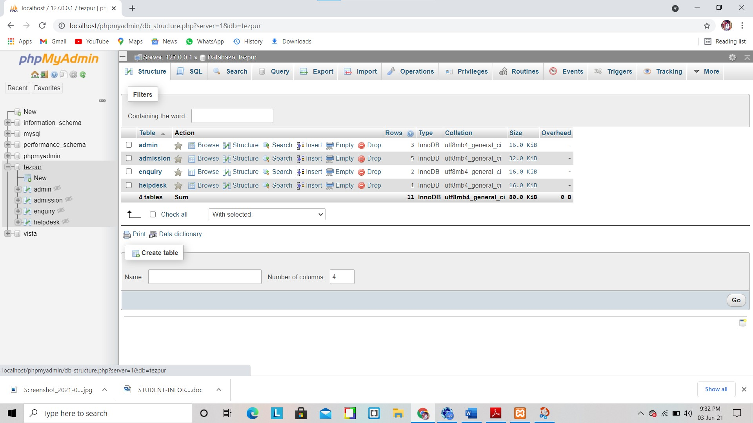
Agra Database
7.2.5 Apache
The Apache HTTP Server is a web server software notable for playing a key role in the initial growth of the World Wide Web. In 2009 it became the first web server software to surpass the 100 million website milestone. Apache is developed and maintained by an open community of developers under the auspices of the Apache Software Foundation. Since April 1996 Apache has been the most popular HTTP server software in use. As of November 2010, Apache served over 59.36% of all websites and over 66.56% of the first one million busiest websites.
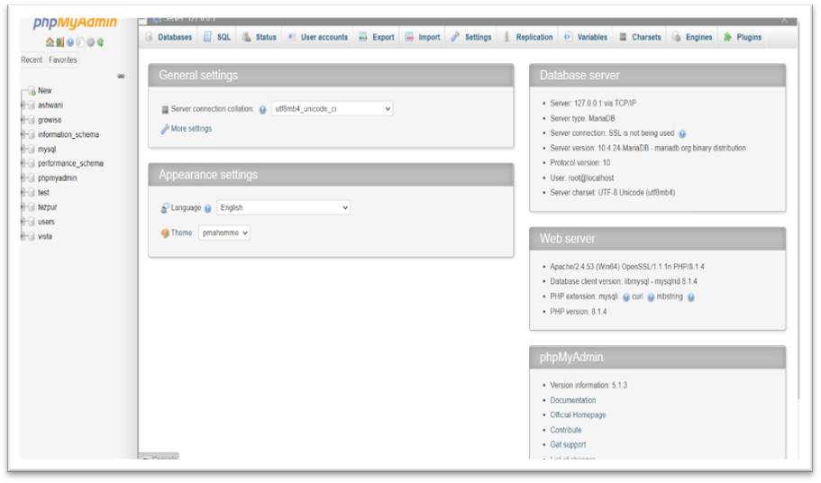
FIGURE 5. Homepage of phpMyAdmin
It is a combination of free-to-use software such as Apache, MySQL, and PHP, so it is offered free of charge. The software used in XAMPP is:

- Apache: It is an open-source HTTP web server and a vital part of XAMPP. Its modular structure helps it to be easily enhanced with the use of add-ons.

- MySQL: It is used to develop a dynamic website. It is the most used relational database system and XAMPP provides an easy-to-use MySQL interface in phpMyAdmin.

- PHP: It is the most commonly used server-side programming language for creating websites

7.2.5 PHP
PHP stands for “Hypertext Preprocessor”. It is a general-purpose open-source scripting language especially suited for web development and is executed on the server. The extension for a PHP file is “. php”. A PHP file can include normal texts, HTML tags, CSS styles, JavaScript scripts, and PHP codes. The PHP codes are executed on the server and the result is passed to a browser as a plain HTML.

Everything happening in the back-end of web development could be done with PHP. It can generate dynamic content. It can collect data from HTML forms and pass it to databases. It also could perform a CRUD (“Create Read Update and Delete”) operation in a database. Admin privileges, normal user, and guest privileges could be set with the help of PHP.

• It is compatible with various OS platforms (Linux, Windows, Unix, Mac OS)
• It could be run on many servers (Apache)
• It can be paired with different databases.

Syntax: A PHP script can be placed anywhere in a document enclosed inside <? PHP and?> as shown in figure 6. PHP statements end with a semicolon (;).
“<? PHP
// PHP code goes here
?>”

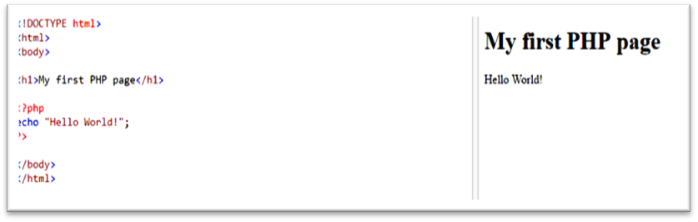
FIGURE 6. Use of PHP in HTML

7.2.6 PHP Framework
PHP is open-source, easy to use, and compatible with different platforms many PHP frameworks have been created for ease of use. A framework in web development can be defined as software that is designed to support the development of web resources, web APIs, and web applications including web services. It provides many predefined functions such as libraries for database access, templates, and session management. Code reusability is one of the most prominent features of any framework.

So, like any other Framework in web development, the PHP framework is a platform that provides structure and allows the user to develop web applications. It is possible to save plenty of time by using the PHP framework as applications can be faster with PHP frameworks. Some of them are listed below: (Site point best PHP frameworks, Date of retrieval 27th May 2018)

- Laravel
- CodeIgniter
- Yii
- Symfony
- CakePHP

Chapter-8
System Testing
During the development of the system unit tests are performed as newer and newer modules are added to the codebase. After each module is added if it is somehow related to some other module in the existing codebase then the integration test is also performed by the testing team.
For the system testing following tests are considered:

- Test the authentication system with valid and invalid email and passwords.

- Test if the authentication system allows duplicate users.

- Test if the authentication system leads the user to the homepage after successful login/signup.

- Check if the failed authentications are handled properly.

- For each action what happens in case of network failure.

The following figure shows one of the test cases that shows the testing of the login screen with the wrong password.

Chapter-9
Hardware & Software Requirements
This section describes the software and hardware requirements of the system:
9.1 Hardware Requirements
- Minimum 350MB Hard Disk space for installation.
- 4GB HD space is required for a typical live system with 1000-2000 events.
- Recommended minimum CPU - Pentium 4, 3.2GHz.
- Recommended 1GB RAM for a Central Server with 3 Nodes.
- Network card.
9.2 Software Requirements
- Application system: Sublime text, Adobe Photoshop, Apache
- Language: XAMPP, Composer, HTML, CSS, Bootstrap, JavaScript

Chapter-10
Results
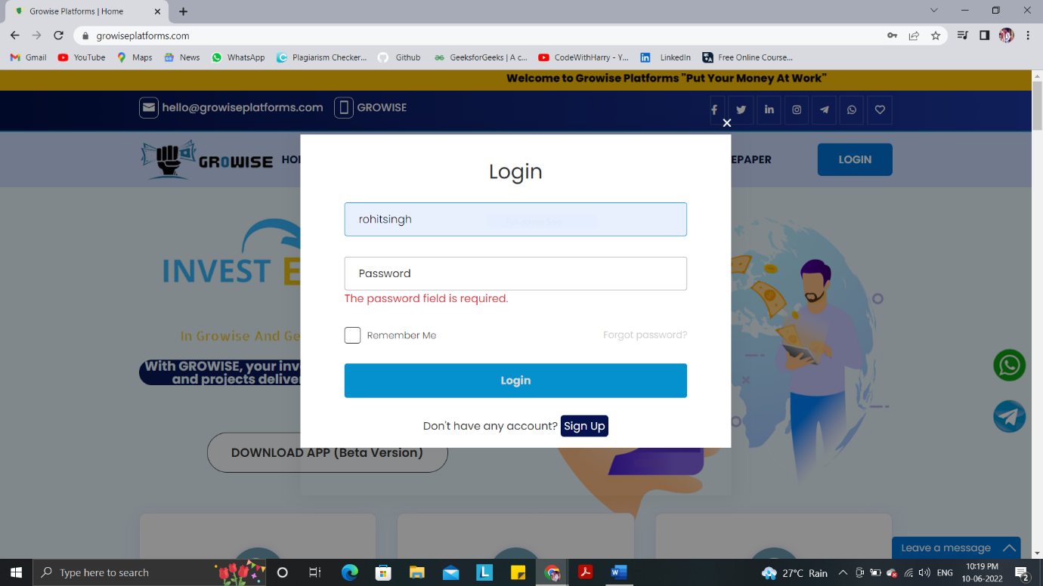
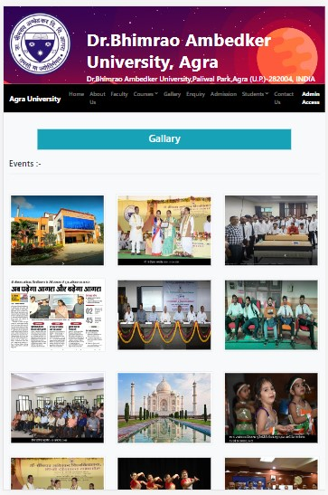
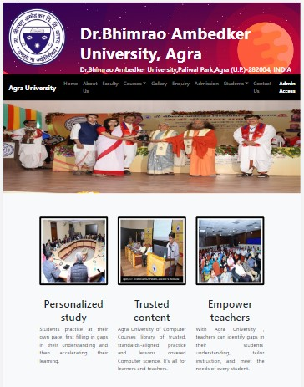

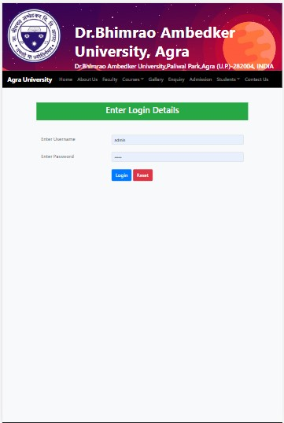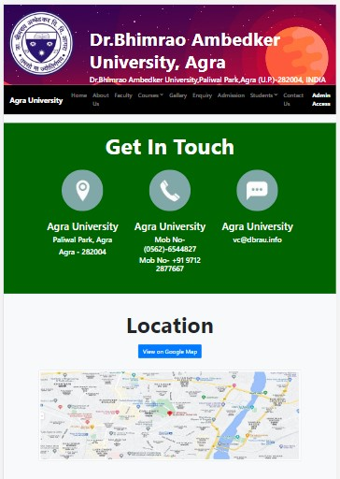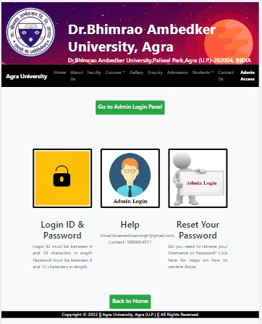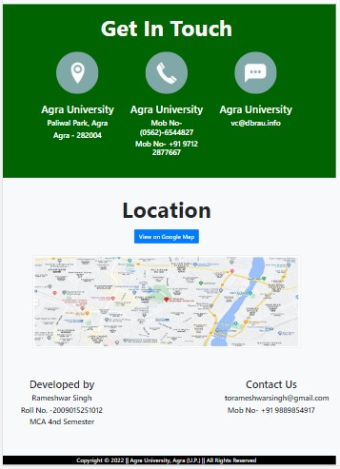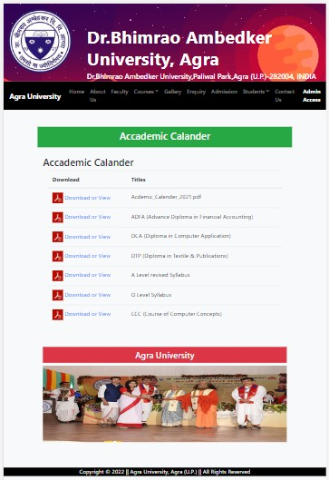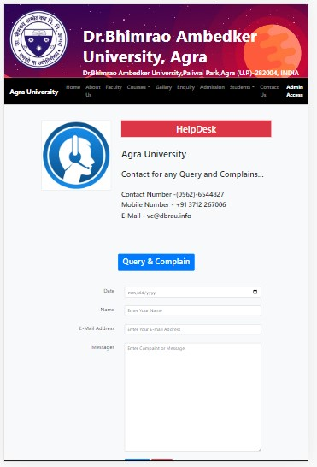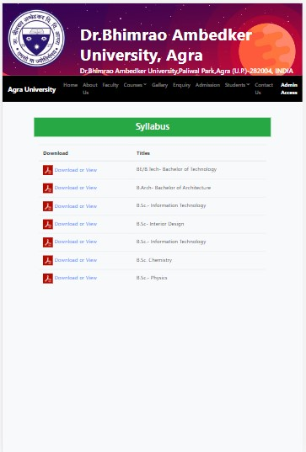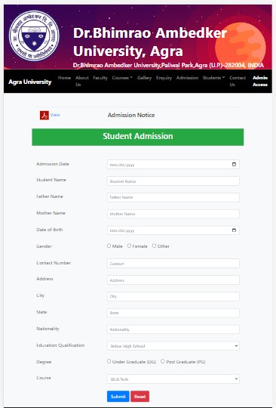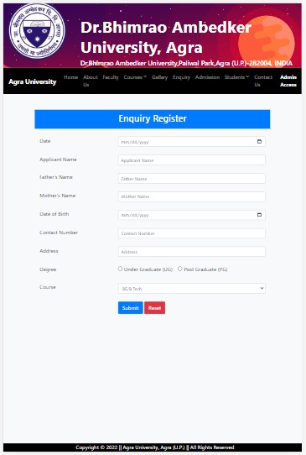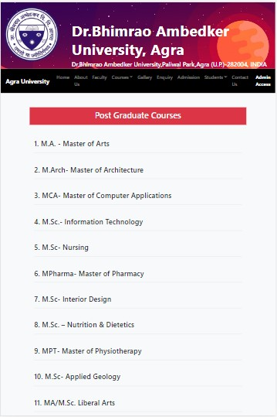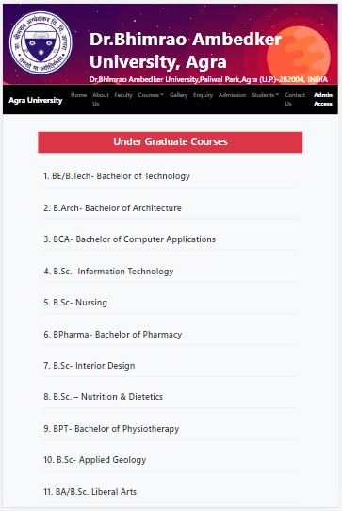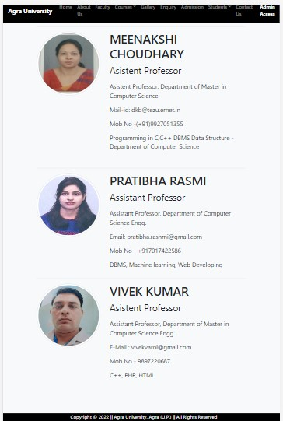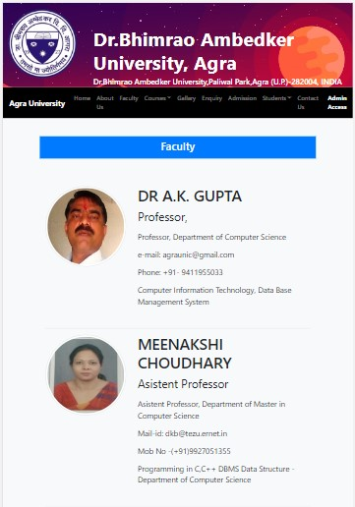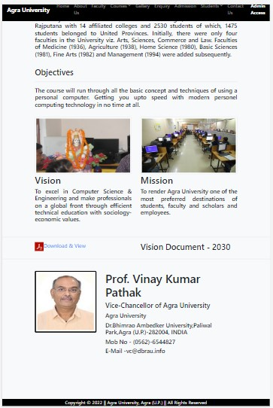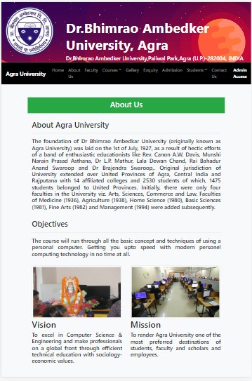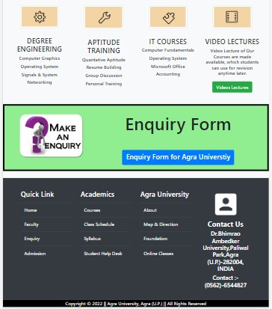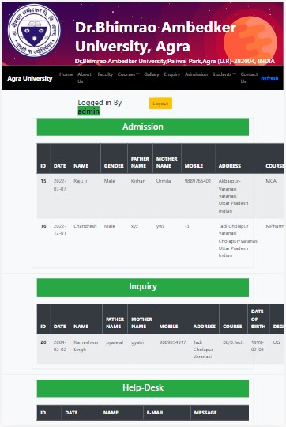

Chapter-11
Conclusions
To conclude, Project Data Grid works like a component that can access all the databases and picks up different functions. It overcomes the many limitations incorporated in the Metaverse projects.

- Easy implementation Environment
- Generate report Flexibly

Working with Agra University as students has helped me to understand what my area of interest is. I have gained an immense amount of technical knowledge from this work experience, and I plan to continue it in my future career. I believe that my commitment as a web application developer won't solely enhance my career path however additionally I have to learn new technologies to improve my ability to create changes in my career path. To extend, as an intern, I have learned HTML, JS, PHP, Bootstrap for web application development, and to code in a way that my code can be easily changeable, reusable, and easy to fix bugs and profitable and a new programmer can use it after. I used HTML, JS, PHP, Bootstrap for my project development and while working with HTML, JS, PHP, Bootstrap, I found it easily learnable, and usable, and there is a bright scope for me to choose to development as a future path. Also, I set myself an achievement list before the beginning of my project for my improvement and I am pleased to inform you that my achievement list was achieved precisely. On the other hand, I have learned to acclimate to working in a development team and also in a professional environment. As a web developer, I gained so much confidence dramatically due to my internship. I am ready to work in a professional organization and eager to contribute to growth and profit with all the skills I have acquired.

Chapter-12
Bibliography
Here I would like to present the name of the books, used for reference while designing, coding, testing, and implementing the project.
- W3schools. HTML Syntax. https://www.w3schools.com
- Getting started with Bootstrap [online] URL: http://getbootstrap.com/getting-started
- CODE ACADEME. CSS Syntax. https://ukacademe.com/WebDevelopment/CSS/CSS_Syntax
- Tutorial Points (I) Pvt. Ltd. JavaScript. https://www.tutorialspoint.com/javascript/javascript_tutorial.pdf
- W3Schools. JavaScript Function. https://www.w3schools.com/js/tryit.asp?filename=tryjs_functions
- Sitebay.com. Bootstrap introduction, why use Bootstrap. https://www.sitesbay.com/bootstrap/index
- W3Schools.BootStrap https://www.w3schools.com/bootstrap/bootstrap_examples.asp
- PhpMyAdmin.net About, Features. https://www.phpmyadmin.net/
- Tutorial Points (I) Pvt. Ltd. PHP Tutorials. https://www.tutorialspoint.com/php/php_tutorial.pdf
- Guru99. Common Features of PHP. https://www.guru99.com/what-is-php-first-php-program.html
- Schema Builder URL: http://laravel.com/docs/
- The PHP package archivist URL: https://packagist.org
- Getting started with Composer URL: https://getcomposer.org/doc/00-intro.md
- WhatisMySQL?URL:http://dev.mysql.com/doc/refman/5.6/en/what-is-mysql.html
- Xampp server [online] URL: http://www.Xamppserver.com/en

